### PROJECT REPORT ON

### " AVALANCHE FORECASTING PREDICTION USING AUTO AI SERVICE "

**BATCH : 1,JUNE ,2020 - 30,JUNE ,2020**

**SUBMITTED BY : SIMRAN KAREER**

**INTERNSHIP TITLE : RSIP CAREER BASIC ML 033**

**PROJECT ID : SPS_PRO_297**

**CONTENTS**

1 INTRODUCTION

1.1 OVERVIEW

1.2 PURPOSE

2 LITERATURE SURVEY

2.1 EXISTING PROBLEM

2.2 PROPOSED SOLUTION

3 THEORITICAL ANALYSIS

3.1 BLOCK DIAGRAM

3.2 HARDWARE / SOFTWARE DESIGN

4 EXPERIMENTAL INVESTIGATIONS

5 FLOWCHART

6 RESULT

7 ADVANTAGES AND DISADVANTAGES

8 APPLICATIONS

9 CONCLUSIONS

10 FUTURE SCOPE

11 BIBLIOGRAPHY

**1. INTRODUCTION**

**1.1 Overview**

Machine learning is a type of artificial intelligence (AI) that provides computers with the ability to learn without being explicitly programmed. Machine learning focuses on the development of Computer Programs that can change when exposed to new data.Machine learning involves computer to get trained using a given data set, and use this training to predict the properties of a given new data.Basics of Machine Learning, and implementation of a simple machine learning algorithm using python.Python community has developed many modules to help programmers implement machine learning.In this paper We have built a web application which predicts the range of avalanche. It is done by building a machine learning model using the best algorithm and integrating it into the flask application.

**1.1.1 AVALANCHE**

An avalanche (also called a snowslide) is an event that occurs when a cohesive slab of snow lying upon a weaker layer of snow fractures and slides down a steep slope. Avalanches are typically triggered in a starting zone from a mechanical failure in the snowpack (slab avalanche) when the forces of the snow exceed its strength but sometimes only with gradual widening (loose snow avalanche). After initiation, avalanches usually accelerate rapidly and grow in mass and volume as they entrain more snow. If the avalanche moves fast enough, some of the snow may mix with the air forming a powder snow avalanche, which is a type of gravity current. Slides of rocks or debris, behaving in a similar way to snow, are also referred to as avalanches .The load on the snowpack may be only due to gravity, in which case failure may result either from weakening in the snowpack or increased load due to precipitation. Avalanches initiated by this process are known as spontaneous avalanches. Avalanches can also be triggered by other loading conditions such as human or biologically related activities. Seismic activity may also trigger the failure in the snowpack and avalanches. Although primarily composed of flowing snow and air, large avalanches have the capability to entrain ice, rocks, trees, and other surficial material. However, they are distinct from slushflows which have higher water content and more laminar flow, mudslides which have greater fluidity, rock slides which are often ice free, and serac collapses during an icefall. Avalanches are not rare or random events and are endemic to any mountain range that accumulates a standing snowpack. Avalanches are most common during winter or spring but glacier movements may cause ice and snow avalanches at any time of year. In mountainous terrain avalanches are among the most serious objective natural hazards to life and property, with their destructive capability resulting from their potential to carry enormous masses of snow at high speeds.

**TYPES OF AVALANCHE:**

1.Wet Avalanches

2.Dry (Powder) Avalanches

3.Dry Slab Avalanches

4.Loose Snow Avalanches

Wet Avalanches : Wet avalanches are triggered by warm air temperatures, sun or rain, causing water to percolate through the snowpack and decreasing its strength. Most avalanche professionals make a hard separation between wet snow avalanches and dry snow avalanches, because they are so different. Much of their mechanics are different, they move differently, and it's only natural for us to think of them as two altogether separate beasts. But really there's a continuum between wet and dry avalanches. Like dry snow avalanches, wet avalanches can occur as both sluffs and slabs. Wet avalanches usually occur when warm air temperatures, sun or rain cause water to percolate through the snowpack and decrease the strength of the snow, or in some cases, change the mechanical properties of the snow. Once initiated, wet snow tends to travel more slowly than dry snow-like a thousand concrete-carrying trucks dumping their loads at once, rather than the hovercraft-like movement of a dry avalanche. A typical wet avalanche travels at 10 to 20 mph (15 to 30 km/h), but on steeper terrain they can go nearly as fast as a dry avalanche. Probably because not as many recreationists are out on wet snowy days, wet avalanches don't account for nearly as many avalanche fatalities as dry snow avalanches. However, they still account for a sizeable percentage of avalanche fatalities in maritime climates (mountains bordering oceans), especially to climbers.

Dry (Powder) Avalanches : Dry avalanches, though beautiful, are extremely violent and seize up like concrete the instant they come to a halt. Dry avalanches are the stunningly beautiful ones that roar down the mountain, light and fluffy, like clouds of powder, but beneath the misty powder cloud is a rushing mass of snow-the "core" of the avalanche-that is a fluidized mix of air (70 percent) and ice particles (30 percent). As the snow rushes through the air it kicks up an envelope of powder, appropriately enough called a "powder cloud," which comprises only about one percent snow and 99 percent air, and this is the part of the avalanche that gives it its beauty. In front of the powder cloud is the invisible "air blast" that pushes out in front of the moving snow. The air blast carries only about one tenth of the impact of the core, but it can travel fast enough to explode your lungs if you are caught by the full impact of the blast. The avalanche is slowed down mainly by friction with the rocks, vegetation, and the snow surface it runs on. The snow nearest the bed travels more slowly than the snow above. Often, if you look close enough, you can see avalanches come down in waves. One wave shoots out, is slowed by friction with the ground and air, and then the next wave-travelling on the back of the first wave-shoots out ahead of the first wave, and so on. It looks like pulses of snow being spat out the front of the avalanche about once every few seconds. The extreme violence inside the flowing debris grinds up all the snow into finer and finer particles, and even if the snow started out light and fluffy, it can become very dense by the time it finally comes to a stop. A large avalanche that starts out with a density of 5 to 10 percent (volume of snow versus air) can often end up as 30 to 40 percent at the bottom. This means that when everything comes to a stop, the dense snow packs very tightly. Also, small grains sinter (coalesce) much more quickly than large grains, and the tiny grains making up avalanche debris can sinter as much as ten thousand times faster than the larger grains of the initial slab. Finally, all of the kinetic energy liberated on the way down heats up the snow a little and creates small drops of liquid water on the surface of the ice grains. Combining all these factors, it's easy to see why avalanche debris seizes up like concrete the instant it comes to a stop. The avalanche victim is frozen in place.

Dry Slab Avalanches : Nearly all avalanche deaths in North America are caused by slab avalanches, caused when a cohesive plate of snow suddenly slides away. A "slab" is a cohesive plate of snow that slides as a unit on the snow underneath. A slab doesn't have to be hard it just has to be relatively stronger than the snow underneath. A typical slab is about half the size of a football field, about one to two feet (30-60 cm) deep, and usually reaches speeds of 20 mph (32 km/h) within the first three seconds, quickly accelerating to around 80 mph (128 km/h) after the first, say, six seconds. The bonds holding a slab in place fracture at about 220 mph (352 km/h) and the slab appears to shatter. Dry slab avalanches can lie teetering on the verge of catastrophe, sometimes for days or even months. The weak layers beneath the slabs are extremely sensitive and the rapid addition of the weight of just one person can easily initiate a fracture on a slope that would not have avalanched otherwise. A slope can sometimes be a giant booby trap-seemingly waiting for just the right person to come along. The crack often forms well above the victim, leaving little room for escape.

Loose Snow Avalanches : Loose snow sliding down a mountain is called a loose snow avalanche. Small loose snow avalanches are called "sluffs." Few people are killed by loose snow avalanches because they tend to be smaller, and they tend to fracture beneath you as you cross a slope, rather than above you, as slab avalanches often do. Most of the people killed in loose snow avalanches are climbers, or extreme skiers and boarders in very steep terrain.

**1.2 Purpose**

Effects of Avalanche:

* **Death of People and Animals** :Asphyxiation is the most common cause of death by an avalanche. People and animals buried deep in the snow suffocate to death due to a lack of oxygen. The force of an avalanche can also break and crush bones easily. People can also freeze to death when buried under several feet of snow. If found within 15 minutes of being buried under an avalanche, there is a high chance for the victim to survive. However, the survival probability decreases with time. Some of the world's deadliest avalanches have caused the deaths of hundreds of thousands of people.
* **Property Damage** : A powerful avalanche can completely destroy buildings and other constructions that come in its way. Houses, shacks, cabins, and even the ski resorts can be ruined during this disaster.
* **Transportation Disruptions** : Avalanches can completely disconnect mountain settlements higher up from the rest of the world. The railroads and roads might have to close down due to the damage caused by the avalanche to the transport infrastructure. Roads might be covered in thick snow from the avalanche that makes the movement of vehicles impossible for days before the snow is cleared off. Cars and trains traveling in the area during the avalanche can also be wiped off or buried under the snow.
* **Communication and Utility Disruptions** : Avalanches can wreak havoc in the lives of the people living in and around the disaster area. Power lines can be broken so that people go without electricity for several days. Telephone and cable lines can also be disrupted leaving people with no way to communicate with others or seek help. Such issues can also delay rescue missions. Oil, gas, and water pipes may burst, leak, or be crushed leading to a lack of supply of these vital requirements.
* **Crop Failure** : If the snow from an avalanche accumulates on farmland located at the lower altitudes, it can completely destroy the crop causing a crop failure and heavy economic losses for the farm. Inorder to keep people to safeside,we made a model on analyzing the previous parameters such as forestdensity,air teaparature,slope etc of an area where severe avalanche occurs frequently which made to cause avalanche.so that,we can able to predict such consequences before itself and we will prepare ourselves to escape from avalanche.

Our objectives for this project:

1. To find out the avalanche occurs or not.

2. To find out how danger the avalanche occurs

**2. LITERATURE SURVEY**

**2.1 Proposed Solution**

This project prevents the people from the avalanche by priory informing them there is a chance to the occurrence of avalanche or not. The model gets the data from the IOT based sensors. After that we want to process those data using a suitable algorithm, then our model display whether the avalanche occur or not and how strength it was. To analyse the data coming from different sensors we are applying various machine learning algorithms. If there is a chance of avalanche then the notification will be sent to people so that they can take decisions accordingly and the model is been built in Auto AI.

Decision Tree Algorithm: Decision tree is considered as the powerful solution to the classification problems and it is applied in many real world applications. Many data mining techniques are used for weather forecasting in the present scenario, with various levels of accuracy. From the Above literature it reveals that there are works which are carried out considering Rule-based Methods, Neural Networks, and Memory based reasoning, Naïve Bayes, Bayesian Belief Networks, and Support Vector Machines. But none of them have attempted identify for Decision tree using data sets hence in this work an attempt is made to predict future weather forecast. A decision tree is a decision support tool that uses a tree-like model of decisions and their possible consequences, including chance event outcomes, resource costs, and utility. It is one way to display an algorithm that only contains conditional control statements. Decision trees are commonly used in operations research, specifically in decision analysis, to help identify a strategy most likely to reach a goal, but are also a popular tool in machine learning. A decision tree is a flowchart-like structure in which each internal node represents a "test" on an attribute (e.g. whether a coin flip comes up heads or tails), each branch represents the outcome of the test, and each leaf node represents a class label (decision taken after computing all attributes). The paths from root to leaf represent classification rules. In decision analysis, a decision tree and the closely related influence diagram are used as a visual and analytical decision support tool, where the expected values (or expected utility) of competing alternatives are calculated. A decision tree consists of three types of nodes: Decision nodes – typically represented by squares Chance nodes – typically represented by circles End nodes – typically represented by triangles Decision trees are commonly used in operations research and operations management. If, in practice, decisions have to be taken online with no recall under incomplete knowledge, a decision tree should be paralleled by a probability model as a best choice model or online selection model algorithm. Another use of decision trees is as a descriptive means for calculating conditional probabilities.Decision trees, influence diagrams, utility functions, and other decision analysis tools and methods are taught to undergraduate students in schools of business, health economics, and public health, and are examples of operations research or management science methods.

**3. THEORITICAL ANALYSIS**

**3.1 Block Diagram**

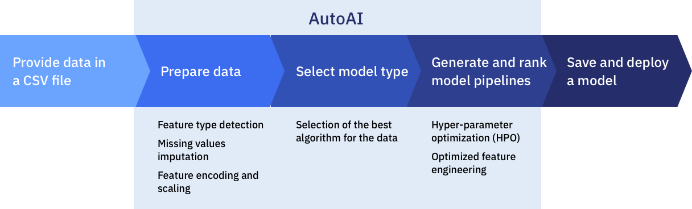

**3.2 Hardware/Software Design**

After creating an account on IBM cloud following steps have to be performed to create the model and the application:

MODEL

The model is built using IBM Watson Studio



* Create project in Watson Studio
* Auto AI Experiment in Add Project
* Setting Up an AUTO AI Environment
* Import Dataset
* Run The Model
* Selection of Auto AI Pipeline
* Deploy and Test the model in Watson Studio

APPLICATION BUILDING

* Create NODE RED service

### Go To Manage Palette & Install Dashboard Nodes

* Build UI with NODE RED

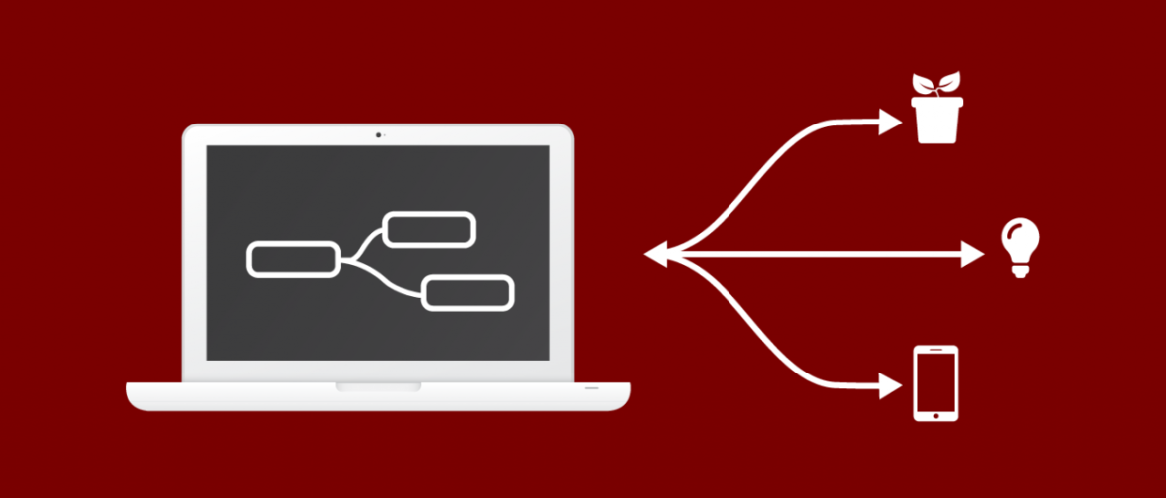

**4 EXPERIMENTAL INVESTIGATIONS**

PARAMETERS

The avalanche danger is a broad brushstroke of daily conditions. ‘avalanche problems’ are an extension of the danger scale and use four factors to give a more nuanced description of the days avalanche conditions,:

a) Date/Time

b) Temperature(deg F)

c) Relative Humidity(%)

d) Total Snow Depth(")

e) Intermittent/Shot Snow(")

### What is the total snow depth?

If the total snow depth is shallow – around 1m and it is cold, well below zero celsius (usual in the early winter), this will develop a weak snowpack.

If the total snow depth is shallow – around 1m and it is warm – around zero celsius and above, then the snowpack will become more stable.

If the snowpack has been deep from the early winter 3m or so, then weak crystals do not form so readily.

If the snowpack is deep and recent it may be lying on a weak lower layer – this increases the avalanche hazard.



**5. FLOWCHART**

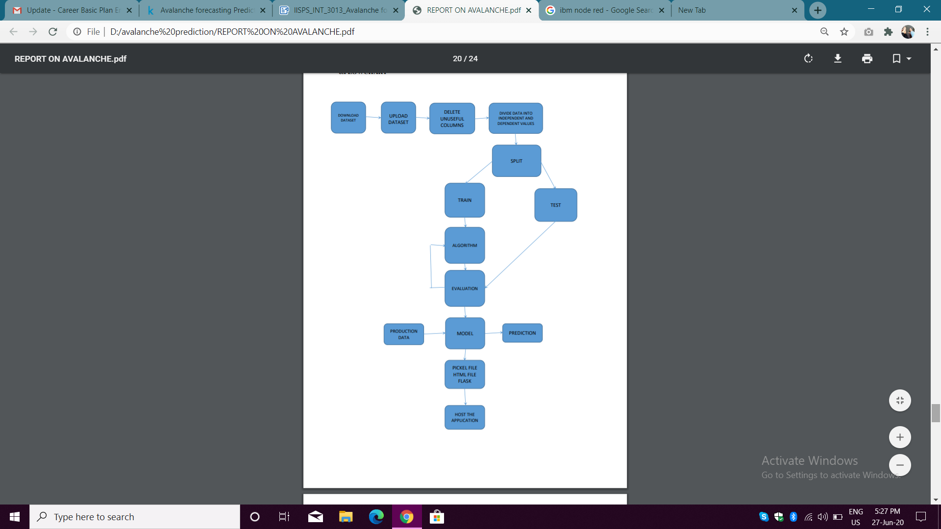

**6 RESULT**

The model is able to predict avalanche with good accurency for the provided parameters.

**7 ADVANTAGES AND DISADVANTAGES**

**Advantages**

● Perfect prediction of the avalanche occurence using parameters

● Very accurate performance calculations.

● Extremely easy interface.

● Straight forward results.

**Disadvantages**

● User should have the idea on all the parameters and units of each parameter.

**8 APPLICATIONS**

1 .It is used to warn the tourists or the wanderers near the mountains to stay away from the slopes by taking the situations into concern

2. It is also used to tell whether the external precipitation occurs our avalanche or not.

**9 CONCLUSIONS**

In this project we used IBM Auto AI Service for prediction of Avalanche.Various parameters were considerd to get the result. The results show how these parameters have influenced the weather observed in these months over the study period. Given enough data the observed trend over time could be studied and important deviations which show changes in climatic patterns identified. Decision trees prove as an effective method of Decision making in Avalanche prediction. This work is important to disaster management studies because the variation in terms of temperature, humidity, etc. can be studied using this service.

The UI output of the project is as follows:



The URL for the project is:

<https://node-red-kzeft.eu-gb.mybluemix.net/ui/#!/0?socketid=KN3LFN7ICqrzvMaUAAAC>

**10 FUTURE SCOPE**

As our model is able to predicts range of avalanche happens in the future,people who are living around that area can able to vacate before it happening.

**11 BIBLIOGRAPHY**

<https://en.wikipedia.org/wiki/Avalanche>

<https://whyfiles.org/105avalanche/4.html>